Republic of the Philippines

National Police Commission

Philippine National Police

**Cavite Police Provincial Office**

**CARMONA MUNICIPAL POLICE STATION**

Brgy Maduya, Carmona, Cavite

***carmonacavitepnp@gmail.com***

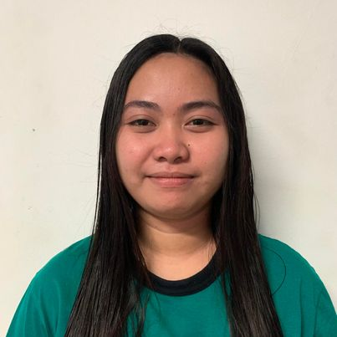

April 5, 2022

**CERTIFICATE OF DETENTION**

**TO WHOM IT MAY CONCERN**

**THIS IS TO CERTIFY** that one **KRIS ANN JOYCE DELOS SANTOS SECO**, female, 20 years old, born on **August 13, 2001**, single, resident of **B52 L51 Southville 5A Phase 2 Brgy. Langkiwa, Biñan, Laguna** was detained at this office since November 26, 2021 up to present and charged for the crime of **“Sec. 13 and 14 ART II of RA 9165”** with Criminal Case Nr. **CAR 2021-922 & 923,** before the Office of Provincial Prosecutor, Imus, Cavite.

This certification is being issued upon request of interested party for whatever legal purposes it may serve.

Prepared by :

Kris Ann Joyce Seco, **PSSg Anderson A Videña**

Detainee Custodial Officer